Application Form
To be read in conjunction with the 2018 Siganto Foundation Medal Information Sheet,
pages 4 and 5 below.

PART 1: PERSONAL DETAILS AND ACADEMIC RECORD

Student Number |  |  | Male Female
Mr/ Miss/ Ms | First name: |  | Family name:
Postal Address:
Suburb: |  | State: |  | Postcode:
Telephone (home) |  | Mobile:
Work/Student Email address:
Other Email address:
Principal PhD Supervisor
Thesis title

Is this PhD affiliated with the QUT Institute for Future Environments? | Yes No
Supervisors Report and Examiners Reports | Please ensure you include a copy of your PhD Thesis Examiners Reports with this application.  Examiners Reports included with this application:  Yes No

PART 2: SELECTION CRITERIA
Please provide your answer to each question in the spaces below.
(No more than half a page per question please).
- Please explain your immediate and future career aspirations, including whether you intend to undertake interdisciplinary post-doctoral activity.

- International dissemination of your research: Explain any past achievements, as well as your future aspirations and plans.

- Please provide a statement about your willingness to participate in educating secondary and tertiary aged students about the benefits of a career in engineering and research.

- Ability and willingness to become an ambassador for the Institute for Future Environments (IFE): Share your ideas on the activities you could potentially perform as an IFE ambassador.

PART 3: Principal PhD Supervisor comments

This section is for the Principal Supervisor of the nominee to provide a statement verifying the candidate’s academic merit and suitability to be awarded the 2018 Siganto Foundation Medal, based on the selection criteria outlined in Part 2 above:

Part 4: DECLARATION & SUPPORTING EVIDENCE

A. DECLARATION

I declare that, to the best of my knowledge and belief, all the information I have provided is true and correct to the best of my knowledge. I understand that the submission of false information in my application will result in the disqualification of my application.

I have read and understood the conditions of the Siganto Foundation Medal.

Signature: _______________________________ Date:________________________
B. TAXATION
You are encouraged to make your own enquiries about the effect of such an award on your tax obligations or any government benefits you are currently receiving or may apply for in the future. Although QUT does not take any tax off the award amount, QUT is not authorised to deem this award tax exempt. Ultimate determination regarding the tax status of the award will be made by the Australian Taxation Office. Please retain this statement with your tax documentation. Additional tax information can be obtained by visiting the Australian Tax Office (ATO) online or telephoning the ATO on 13 28 61.

C. PRIVACY DECLARATION
QUT collects the personal information on this form to assess your application and for other University purposes upon enrolment. The collection is authorised under the QUT Student Rules. Information explaining how QUT manages students' personal information, and our practices for disclosure, can be found at www.governance.qut.edu.au/compliance/privacy/

APPLICATIONS WILL ONLY BE CONSIDERED IF RECEIVED BEFORE

Midnight, Sunday, 8 July, 2018

APPLICATIONS MUST BE LODGED:

By Email to sef.research@qut.edu.au

Please attach one file with all necessary information included.

Subject: “Siganto Foundation Medal application”

Att: SEF HDR Awards

Information Sheet

Official presentation of the 2018 Siganto Foundation Medal

Applicants are asked to make themselves available for an official presentation of the Siganto Foundation Medal, which will be attended by representatives of the Siganto Foundation.

Details will be arranged in consultation with the successful applicant and Siganto family representatives.
To be read in conjunction with the Siganto Foundation Medal 2018 Application Form.

The Siganto Foundation Medal
The Siganto Foundation Medal was established through generous gifts from The Siganto Foundation, led by the late Dr Bill Siganto AM and Dr Marie Siganto AM, to support distinguished PhD graduates from the QUT Science and Engineering Faculty for the purpose of knowledge dissemination, global recognition and career progression in the field of Engineering.
This special award recognises excellence in engineering-related PhD research and provides encouragement for the recipient to undertake post-doctoral activity.
In addition to the 2018 Siganto Foundation Medal, the recipient will receive a $10,000 award, funded jointly by The Siganto Foundation and QUT’s Institute for Future Environments to allow the medallist to undertake multidisciplinary professional development and research activities both locally and internationally.

Conditions of the Award

To be eligible to apply for the 2018 Siganto Foundation Medal you need to have studied your engineering-related PhD through the QUT Science and Engineering Faculty and completed all requirements to graduate with your PhD between 1 January, 2017, and 31 May, 2018.

As part of the application process for The Siganto Foundation Medal you will be required to exhibit excellence in your chosen field of engineering research and demonstrate your intention to undertake postdoctoral activity.

During the year of being awarded the medal, the winning student will be expected to provide a medal impact report detailing the following:

• The impact the Medal and the associated grant made to their career direction and ambitions

• The additional knowledge and networks gained through international activity

• The feedback from talks conducted at the Secondary School and Undergraduate level, if applicable.

Confidentiality of your application

All information and documentation supplied by you will be treated confidentially and in accordance with QUT’s privacy policy. It will only be disclosed to those people who are involved in the selection process.

Selection process for the 2018 Siganto Medallist

A selection panel comprised of QUT academic leaders will allocate The Siganto Foundation Medal based on information provided in the application.

If the Panel deems it necessary, the final shortlist of candidates will be required to attend a 20 minute interview with the Panel. The interview will be designed to assess the candidates in greater detail against the selection criteria.

Application process: Ensure you include ALL required documentation
Only complete applications will be considered by the selection panel. To ensure your eligibility please:
- complete the application form – be sure to answer every question in Parts 1 and 2, and seek comments from your Principal PhD supervisor in Part 3;
- make sure you include copies of your PhD Thesis Examiners Reports;
- sign the declaration;
- return to the Science and Engineering Faculty via email to sef.research@qut.edu.au by midnight, Sunday, 8 July, 2018.

For further information please contact:

SEF Research Services, QUT

Telephone: 07 3138 1950 or 3138 2156

Email: sef.research@qut.edu.au

ABOUT THE SIGANTO FOUNDATION
The late Dr Bill Siganto AM, QUT Honorary Doctorate, former QUT Council Member and former Deputy Chancellor, was known for shaping vocational education in Queensland and Australia. He was awarded his AM in 1997 for service to tertiary education, particularly as Chairman of the Queensland Vocational Education and Training and Employment Commission, and to the air conditioning and engineering industries. Bill was one of the best known figures in the Australian Heating and Air Conditioning industry and he passed away peacefully on 18 September 2015.  The Siganto Foundation was created in 2006 by Bill and his wife, Dr Marie Siganto AM, to support community initiatives in various areas including the arts, education, social welfare and medical research. In 2011 Bill collaborated with QUT through his family Foundation to create the Siganto Foundation Medal as a major new award for talented QUT engineering PhD students. This will be a lasting legacy of Bill’s contribution to education in Queensland. | 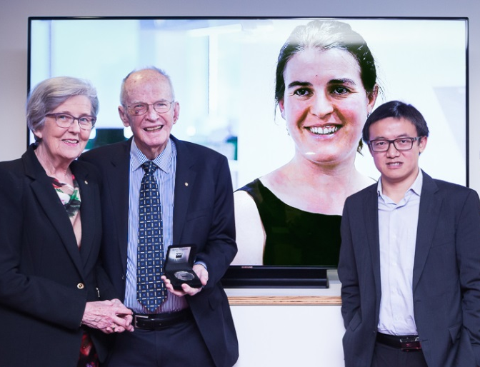  2015 Siganto Medal Presentation Pictured from left: Dr Marie Siganto AM, Dr Bill Siganto AM, Dr Stephanie Lowry (2015 Siganto Foundation Medallist, on screen), and Dr Jun Wang (2013 Siganto Foundation Medallist)
About Siganto and Stacey
Established in 1968 by Bill Siganto and the late Sid Stacey, Siganto & Stacey was founded on an opportunity that arose when contracting equipment companies ceased supply. This loss presented a clear niche in the market to provide a unique combination of engineering, sheet metal, plumbing and manufacturing expertise as well as on-site installation services.
The partnership bought together Sid Stacey’s expertise in sheet metal fabrication, installation and plumbing, and Bill Siganto’s engineering and management skills. Both Sid and Bill recognised their clients’ need for an extensive range of capabilities and so began a long history of changing the way the construction industry thought about air conditioning, heating and ventilation.
In the 1980s Siganto & Stacey moved away from one-size-fits-all air conditioning systems to provide custom designed systems tailored to the client’s requirements. Pioneering this model in Queensland and New South Wales, Siganto & Stacey was one of the first in the industry to bridge the gap between the use of traditional air conditioning practices and the design and construction of innovative engineering solutions.
The 1990s saw Siganto & Stacey complement its engineering and design services with construction and project management in an effort to assist clients to gain time and cost efficiencies.
Now trading as Siganto Air Services and Solutions, the company offers a fully integrated service capability which includes the planning, maintenance, repair, installation, and performance management of commercial and industrial air-conditioning, refrigeration and building management systems across South East Queensland.

